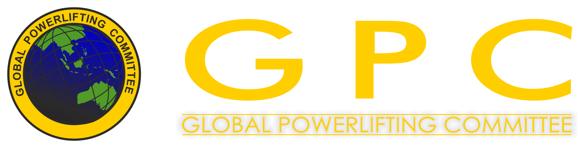

GPC WORLDCUP 2015
Hungarian Powerlifting Congress

Locality: Hungary - 5525 Füzesgyarmat, Széchenyi str. 2.

http://www.telepules.com/fuzesgyarmat/turizmus/szabadido/sportcsarnok-8195.html

Director: Szabolcs Szőke 00 36 30 201 6081

Headmaster of the competiton: Sándor Freimann 00 36 30 520 9193
Date: 5-6-7-8th November 2015.

Weigh-in:

Those competitors who take part on 5th November,
have to weigh-in on 4th November from 08:00 to 10:00 or 17:00 to 19:00.

Those competitors who take part on 6th November,
have to weigh-in on 5th November from 08:00 to 10:00 or 17:00 to 19:00.

Those competitors who take part on 7th November,
have to weigh-in on 6th November from 08:00 to 10:00 or 17:00 to 19:00.

Those competitors who take part on 8th November,
have to weigh-in on 7th November from 08:00 to 10:00 or 17:00 to 19:00.

Official opening ceremony: 9: 30 AM, 5th November 2015

Start of the competition: each day from 10:00 AM

Days of the Competition:
5th November 2015 - RAW bench press in all age and body weight categories.
6th November 2015 - RAW powerlifting + RAW deadlift in all age and body weight categories.
7th November 2015 - EQUIPPED bench press in all age and body weight categories.
8th November 2015 - EQUIPPED powerlifting + EQUIPPED deadlift in all age and body weight categories.

Rules: The Worldcup is organised and will be held by the GPC rules.

These rules are available on the official site of GPC.
(You can find it on the link below.)

http://www.worldgpc.com/index.php/downloads/category/16-rulebook

Entry fees:

Teens, Juniors, Master categories: the first entry fee is 30€ , every further entry costs 20€.

Open category: the first entry fee is 40€, every further entry costs 25€.

Closing day of the entry: 9th October 2015.

The entries can be done on http://www.powerlifting.hu/hu_index.php?page=versenyek with using the „Online entry” option (of course in the time before deadline). However, the entry is only completed, if your entry fee has been paid.

The entry fees have to be transferred/PAID by the closing day of entry to the competiton!

The entry fees should be transferred (or paid) to the following bank account number, and we ask you to write the name of the competitors to the „Notice for transfer” heading!

Bank: Rajka és Vidéke Takarékszövetkezet
Address of the Bank: H-9200 Mosonmagyaróvár, Palánk u. 8.
SWIFT-code: TAKBHUHB
Owner of the account: Hungarian Powerlifting Congress
Owner of the account’s address: H-9200 Mosonmagyaróvár, Kálnoki u. 11.
IBAN: HU82 5950 0155 5001 3667 0000 0000

For further information please contact: Hungarian Powerlifting Congress hungarianpowerliftingcongress@gmail.com
Or visit the following websites: http://powerlifting.hu/ ; www.worldgpc.com

Accomodation possibilities:
http://www.hotelgara.hu
http://www.kastelyfurdo.hu
http://www.kiskastelyfogado.hu
