 

**Alexsander Tosic Anita Mahony**

**Meet Director World GPC Secretary**

[**aleksandar-tosic@live.com**](mailto:aleksandar-tosic@live.com)[**worldgpcsecretary@gmail.com**](mailto:worldgpcsecretary@gmail.com)

**+38-1637487256 +353-86-8422018**

**GPC WORLD CHAMPIONSHIPS 2016**

**in POWERLIFTING, BENCHPRESS & DEADLIFT**

**Location: Knjaževac, Serbia (Culture Center of Knjaževac, B.Radicevica street 1, 19350 Knjaževac)**

**Meet Director: Aleksandar Tosic & Ujedinjeni Srpski pauerlifting Savez (United Serbian Powerlifting Federation)**

**Dates: 18th – 24th September 2016**

**Lifting Schedule:**

**Daily commencement times & schedule will be posted after the closing date.**

|  |  |
| --- | --- |
| **Sunday 18th September** | **Equipped Benchpress & Equipped Deadlift – All Lifters** |
| **Monday 19th September** | **Equipped Powerlifting Women & Men (-56kgs to -90kgs)** |
| **Tuesday 20th September** | **Equipped Powerlifting Heavyweight Men (-100kgs to +140kgs)** |
| **Wednesday 21th September** | **Raw Benchpress & Raw Deadlift - All Lifters** |
| **Thursday 22th September** | **Raw Powerlifting - All Women and Lightweight Men (-56kgs to -75kgs)** |
| **Friday 23th September** | **Raw Powerlifting – Middleweight Men (-82.5kgs & -100kgs)** |
| **Saturday 24th September** | **Raw Powerlifting – Heavyweight Men (-110kgs to +140kgs)** |

**Weigh-In Schedule:**

**All weigh-ins take place the day before lifting commencing 17th September.**

**There will be no weigh-ins on the day of lifting**

|  |  |
| --- | --- |
| **Daily Weigh in Times** | **8am – 11am & 4pm –5pm** |
| Each session can be extended if required to accommodate the number of athletes weighing in who are there by the close of the official weigh in time. | Lifters requiring special weigh-in arrangements due to travel connection times must contact the organiser in advance to organise same. |

**Rules:** These Championships will be conducted using the GPC Rules. The Rulebook is available to download from the GPC Website

**Categories: All GPC Weight Categories & All GPC Age Divisions**

**Raw and Multiply**

**Paralympic* -** Lifters competing in this category must be able to use the standard lifting equipment as the GPC does not have specialised equipment. Lifters who cannot complete the lifts as per GPC rules and who have a disability, must enter the Paralympic category for their Age/Weight division. Lifters with a disability who can complete the lifts as per the GPC rules can opt to lift in the Paralympic category or standard category.

**Entry Fees: First Event €64 - Open & Masters / €44 - Juniors & Teens**

**Additional Events €35 per event**

**Late Entry Fees** (paid after closing date or at weigh-in) **plus €30 per person**

**As per new rules brought in on 01/01/16, all lifters must pay their entry fees to their national federation. The national federation is responsible for submitting the team list and team payment by the closing date to avoid the late penalty fees. All entry fees must be paid in the currency of the organising nation which is Euro for this event.**

**Closing Date: 1st August 2016.** Team List & Entry Fees must reach the Meet Director by this date, otherwise late entry fees will apply. Each nation must set their own closing dates for lifters to submit their entry for inclusion on the team list.

**To Enter:** Team Lists to be emailed to **Alexsandar Tosic**  [**aleksandar-tosic@live.com**](mailto:aleksandar-tosic@live.com)

and **World GPC Secretary** - [**worldgpcsecretary@gmail.com**](mailto:worldgpcsecretary@gmail.com) by 01/08/16

Entry fees must be submitted to the Meet Organiser by 01/08/16.

EURO correspondent is:             AGRIFRPP – Credit Agricole Paris

Acc. With Instruction: 57A:    MEBARS22**,** CREDIT AGRICOLE**,**

SRBIJA AD, Novi Sad

Beneficiary: 59:                         IBAN RS35330007070000043337

Name:                                         UJEDINJENI SRPSKI PAUERLIFTING SAVEZ

Serbian lifters should contact Alexsander Tosic for the bank account to pay in RSD

**Eligibility:** All lifters must be members of the GPC. Each nation sets their own entry requirements. Lifters must enter through their national federation.

Lifters from countries which are not members of the GPC, can apply for Individual Membership of the GPC (Form available on GPC website). [**http://www.worldgpc.com/index.php/downloads**](http://www.worldgpc.com/index.php/downloads)

**Websites:** All information will be included on the championships website:[www.gpc2016.comwww.gpc2016.com](http://www.gpc2016.com/) [**http://u-spf.com**](http://u-spf.com/)

& event facebook page: [**https://www.facebook.com/gpcworlds2016/**](https://www.facebook.com/gpcworlds2016/)

Also the GPC website: [**http://www.worldgpc.com/**](http://www.worldgpc.com/) & GPC Facebook Page: [**https://www.facebook.com/groups/106265919454582/**](https://www.facebook.com/groups/106265919454582/)

The list of competitors can only be posted after the closing date.

**Visas:** If you require a visa compete in these championships, please complete the VISA Support Letter Form available under downloads on the GPC website ([**http://www.worldgpc.com/index.php/downloads**](http://www.worldgpc.com/index.php/downloads)**)** and return to the World GPC Secretary. Lifters must be members of the GPC affiliate in their country or if from a country which doesn’t have a GPC affiliate, must join as individual GPC members before requesting a VISA Support Letter. Individual Membership forms are also available under downloads on the GPC Website.

**ACCOMMODATION**

Accommodation is provided in 5 official hotels and 2 guest house which the organiser has hired out for the championships:

Hotel Mali Predah,

Hotel Barka,

Hotel Milošev Konak,

Hotel Timok,

Etno selo Srna,

Vila Katarina

Dom učenika,

The hotel reservations are accepted by organiser, Ujedinjeni Srpski pauerlifting Savez (United Serbian Powerlifting Federation), Cara Dušana 26, 19350 Knjaževac,  [**aleksandar-tosic@live.com**](mailto:aleksandar-tosic@live.com)

The accommodation must be booked before 20th of August 2016. After that date, the organiser doesn´t guarantee availability of accommodation. Payment for accommodation should be paid on the spot in each individual hotel/guest house.

Accommodation information will be udated on the championships website: [**http://u-spf.com/gpc-world-2016/**](http://u-spf.com/gpc-world-2016/)

**TRANSPORT**

Transfer from airport Nikola Tesla, Belgrade (300km) or bus/train station in Belgrade will be provided by organizer:  We will have 8 passenger vans waiting for you. Transportation price depends on number of passengers per van:

7 or 8 passengers – 55,00 € per person – return ticket

6 passengers – 65,00 € per person – return ticket

5 passengers – 77,00 € per person – return ticket

4 passengers – 95,00 € per person – return ticket

3 passengers – 125 € per person – return ticket

Transfer from Sofia Airport (170km)

7 or 8 passengers – 30,00 € per person – return ticket

6 passengers – 35,00 € per person – return ticket

5 passengers – 45,00 € per person – return ticket

4 passengers – 50 € per person – return ticket

3 passengers – 70 € per person – return ticket

Prices from Nis airport (65km) range from €13 to €33 per person – return ticket.

All transport request needs to be send to email: [a**leksandar-tosic@live.com**](mailto:aleksandar-tosic@live.com)

**BANQUET**

A banquet will be held in the Culture Center of Knjaževac on Saturday 24th of September 2016 at 22:00  (10.00 pm). Lifters who want to attend the banquet, must indicate it on entry form

**PHOTOS**

**CITY & VENUE:**

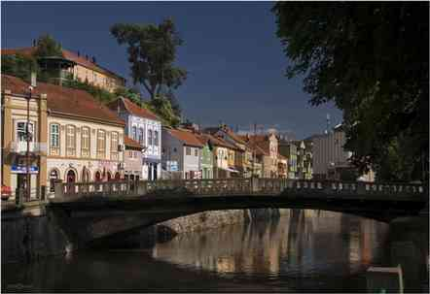

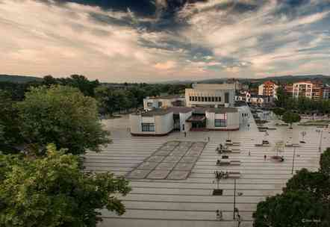

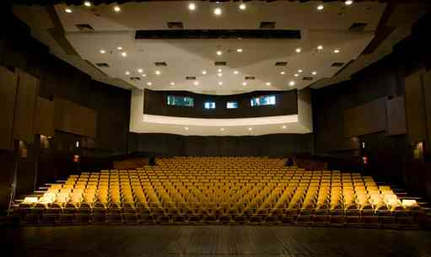

**PREVIOUS EVENTS AT VENUE:**

